

**HWYP Marketing Strategy Report**

**Prepared for**

Dianne Loots,

Horse Whispering Youth Program

**Team Mentor**

Rachel Chung

**Prepared by Team Parra**

Duy Nhan Ta

Shannon Wichmann

Vanlyda Neang

Anuj Shukla

Wenlin Yao

**Executive**

**Summary**

The **Horse Whispering Youth Program (HWYP)** is a non-profit organisation that is established to help young people dealing with complex life situations, learn to connect, trust, respect and cooperate with others through developing healthier emotional control and behaviours. In order to achieve their vision, **HWYP** need funds to provide their service and continue their operation. The objective of this report is to demonstrate HWYP’s marketing situation and effective marketing campaigns. It is intended to provide recommendations on the best marketing channels to promote awareness of HWYP’s charity work and lift **HWPY**’s profit to increase donor and sponsor funding. Four outcomes of marketing campaigns have been introduced in this report including the strategies on social media branding, identifying target sponsor personas, insight about target group and a tactical planning on charity events with media coverage. In addition, the online survey was conducted to gain real insight about the target group.

Four outcomes outline the recommendation that, firstly, using free social media platforms to get connect to target sponsors and donors throughout the world, in addition to develop an effective content strategy by using the hashtags, post and colours. Second, identifying and exploring the characteristics, advantages and disadvantages of each sponsor including individual sponsors, in kind donations, grant from foundation and the extra income from services. Third, get to know the real insight of the target group resulting from online surveys. Fourth, promote **HWYP** through the variety of events ideas including the creation of new physical or virtual events or enlisting in an existing event.

**Table of Content**

|  |  |
| --- | --- |
| Organisation Introduction & Client Requirements | 4 |
| Recommendations |  |
| Outcome 1: Social media branding and strategies |  |
| Outcome 2: Specifically targeting the sponsors |  |
| Outcome 3: Customer insights about the target group |  |
| Outcome 4: Organising an event and getting media coverage |  |
| Conclusion |  |

**Organisation Introduction & Client Requirements**

The **Horse Whispering Youth Program (HWYP)** is an ACNC registered non-profit, horse assisted life coaching program. It has been operating for over 10 years out of Tallebudgera, Queensland. It has been run by volunteers and has been delivering a life coaching program to youths between the age of 8 and 16 from a variety of disadvantaged backgrounds. The coaching program mainly focuses on anger management, anxiety, depression, self-control, and confidence-boosting for youths. As youth crime in the area of Gold Coast is quite evident, programs like these are a good way of providing justice to the youths and managing their anger and anxiety. The program mainly gets its admissions from psychotherapists and Queensland Police (correctional centres) and charges them a very small service fee for each referral. Due to the nature of the activity and background of the admissions, the organisation is not able to charge them any fess. They are currently relying on referral fees and individual donations from donors.

The client is seeking to attract a variety of donors/sponsors who are willing to donate funds to support the HWYP, which is to be addressed by delivering an effective marketing campaign. The campaign consists of social media branding strategies, different types of donations, insights around probable donors, and strategies around organising fundraising events.

This crucial challenge for the organisation is to ensure privacy is taken into account whilst developing the marketing strategies and to achieve the goals of the HWYP and at the same time achieving broader coverage to focus on attracting sponsors. Through achieving this marketing challenge, the program will have the ability to gain sponsorships, which will enable them to breakeven, and still have some profits go towards marketing activities and employment costs (to give to the volunteers who aren't paid).

**Recommendations**

**Outcome 1- Social media branding and strategies**

**Google ad grants**



(Source- Google.com.au)

Google Ad Grants is by far the most generous and impactful ad reservation program available right now. They work with more than 20,000 non-profits around the globe and help create an impact. Google offers $10,000/month worth of ad coverage to the non-profits for free.

To be eligible for applying to the program, below are the [eligibility](https://www.google.com.au/grants/eligibility/) requirements that the organisation will have to meet:

· The Organisations must hold a valid charity status

· Acknowledge and agree to Google’s required certifications regarding nondiscrimination and donation receipt and use

· Have a high-quality website that meets the Ad grants website policy

· Get approved through the Ad grants pre-qualification process after your organisation is enrolled in Google for non-profits.

After being eligible, below are the steps to get started with the [application](https://www.google.com.au/grants/how-to-apply/):

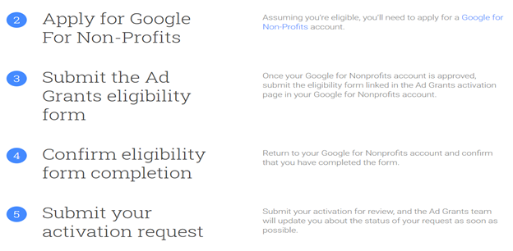

(Source- Google.com.au)

If your application gets successful, you will now have to focus on how effectively utilise those funds and convert them into clicks.

In 2020, with the pandemic having changed the world by making millions of people redundant and much more work from home, those people are googling to find ways to control their anger, self-confidence, depression, anxiety, etc. Now, for example, if you could bid for Adwords around these terms, there is a high possibility that your ad might come up, and people who are looking for this might get interested in having a look at your website. Perhaps, even donating some amount. Secondly, with the current news focusing on the overhauling of the laws around youth justice in Queensland, this could also be a good Adword to consider.

Likewise, there are many more terms and areas such as horse, non-profits, and youth justice that you could explore regarding your organisation. Below are some suggestions of the terms that you could consider bidding on.

1. Donate

2. Charity

3. Non-profits

4. Volunteer

5. Youth

6. Youth Justice

7. Juvenile Justice

8. Juvenile correctional centres

9. Anger management

10. Anger management for Children/ kids/ youth (more specific)

11. Self-confidence

12. Personality boosting

13. Anti-Depression

14. Horse

15. Pony

16. Horse riding

**Optimising Facebook page**

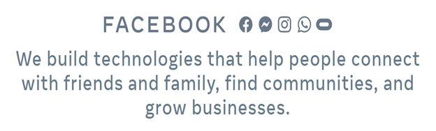

(Source- about.fb.com)

Facebook is a leading social media platform to get connected with people and the community. Facebook has helped raise $3 billion+ for the community through its platform. It is quite evident that Facebook crowdfunding has seen immense support from the people.

Hence, non-profits need to have a very evident, easy to find, engaging, and impactful Facebook profile. Although it seems that the Horse Whispering Youth Program’s Facebook page has gotten quite active in terms of posting, we feel there is a scope for improvement further. We have a couple of suggestions that could make your page stronger, impactful, and attract more donations.

(Source- Canva.com.au)

1. Enable the “Donate” button on your Facebook profile

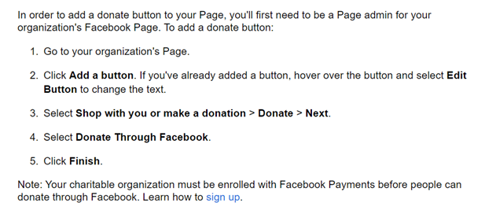

(Source- https://www.facebook.com/help/269698566852985)

2. Create a set posting schedule

·  [Marketing Sherpa](https://www.marketingsherpa.com/article/chart/demographics-why-customer-follow-brands-social-media) wrote that about 95% of adults aged between 18-34 tend to follow brands on social media. This means social media plays a very big role in engaging people, most importantly adults. Hence, a set posting schedule will enable your organisation to post its activities and engage with the donors more frequently. Often organisations with active social media presence attract more donations.

3. Make the content more engaging- Hashtags, Q&A, Polls (discussed briefly in activity 4)

4. Make your Facebook profile, posting templates, donation receipts, email template, and the website colour coordinated (discussed briefly in activity 4)

**Optimising marketing strategy**



(Source- PCMag.com)

You should consider cold email or targeted email as one of the best marketing option. It is because of its nature and its cost-effectiveness. After Hashtags (discussed in activity 4), emails can be considered one of the very cheap marketing tools. According to the Hellostepchange website, email is one of the best ways to attract donations. Reports suggest, on average there was a return of investment of $44 for every $1 spent.

There are many marketing email websites such as MailChimp, Mailgun, Klaviyo, etc. in the market. However, MailChimp and Klaviyo have some really good email marketing plan, where Klaviyo lets you send 1,000 emails to up to 250 of your contacts for free. Whereas if you can spend $14.99/month, MailChimp lets you would send about 6,000 emails to up to 500 contacts, which seems best in the segment offering. Along with it, both the websites give you access to their data analytics and click data reports.

**Develop a content strategy (Hashtags, post & content strategy)**

Having a proper content strategy is of the essence for any organisation (be it for profit or non-profit) to promote their products or cause. As quoted earlier in the earlier activity, [Marketing Sherpa](https://www.marketingsherpa.com/article/chart/demographics-why-customer-follow-brands-social-media) estimates that about 95% of adults aged between 18-34 tend to follow brands on social media. Hence, having an engaging content strategy is of the utmost importance. In regards to a non-profit organisation, it is very important to make the probable donors feel that the organisation carries out activities that actually make a difference by upbringing the youth and boosting their self-confidence. Along with it, the organisation would also have to make sure that their existing donors feel respected. Hence, posting about the activities carried out, and children helped will keep the existing donors’ donation flowing in.

An ideal content strategy would include a good focus on the following things:

1. **Consider offering recurring donation and let people know how important their donation is to the organisation.**

According to Hubspot, offering a recurring donation option will help you get a continuous flow of donation, and you will not have to reach to donors often. Further, Formstack mentions in one of their articles that on an average, there was a whopping 42% increase in revenue than the previous year when only on-off donation options were offered. This provides a clear evidence of the effectiveness of recurring donations. However, when trying to attract recurring donations, it is very critical that you show how important that donation is to your organisation, and for the broader community. For each and every type of donation you offer, the donor expects to get a brief of how that donation make a difference, even if it is for a single child.

Below are two proposed strategies for optimising the donation campaign. As per the client requirement, we have focused on dividing the donation campaign in two parts, one campaign attracting donation towards Children, and the other campaign attracting donations towards Horses. One of the best examples to have as a reference, is WWF Australia’s [website](https://donate.wwf.org.au/donate/monthly-donation/monthly-donation#gs.two3c3). We think they have done a really good job in terms of providing a clear brief as to what noble cause they are involved with, and how potential donations could make a difference to the World.

**Donation campaign**

- **Engaging Cover Picture**

We would say, a cover picture is of the most essence in any donation campaign. This is because, a cover picture can deliver a clear message about the activities carried out by the non-profit organisation. This can prove to an important factor for, as an engaging cover picture could make the donor feel the organisation’s true motto and perhaps, believe on them.

-For Children

Here, we suggest you to include only one cover picture but an impactful one. Probably a candid picture of an early teenage child in one of your ongoing lessons. Quite often those natural and candid pictures tell the true story.

-For Horses

Same as in children’s donation, an impactful cover picture can be the very first impression of your campaign, and so it is very important that you choose a very engaging picture. For horse’s donation campaign, we suggest you to use the cover picture of Sue’s book, “Horses who heal”. That looks quite engaging.

- **Engaging Content and Heading**

The intentions should be conveyed in a very straight forward manner. Hence, having a big heading such as “Donate for a better tomorrow” in bold and bright colours can clearly convey your intentions about seeking donation

The main content that goes into the template is also very important. When you are updating the website, you might want to put substantially more detail than in a template for a social media post. When posting on social media, it is important to remember that people often like to spend much less time reading all the contents mentioned there. Hence, for social media purpose, you could consider the following suggested content.

For Children

***With the ever increase problem of youth crime, we feel fortunate enough for being able help youths dealing with complex life situations such as anger issues, anxiety, and depression through our horse-assisted programs. These programs are aimed towards providing self-confidence, anger management, and anti-depression lessons to youths coming from various disadvantaged backgrounds.***

***We hope you can do your bit towards securing Aussie Kids’ future by donating today.***

For Horses

***Horse Whispering Youth Program is an equine assisted youth development program aimed towards providing interpersonal communication skills, body language, emotional intelligence, anger management, and anti-depression lessons to the less fortunate youths coming form various disadvantaged backgrounds. Horses play the main role in this therapy by facilitating immediate behavioural changes like developing the ability of handling stress and complex situation in youths. With the help of this program, one can understand how their emotions affect their horse’s performance,***

***Would you like to promote this unique and noble cause by donating towards help our horses?***

- **Monthly Donation option**

When offering recurring donations, it requires some good reasoning and explanation about how it will be used. We suggest you to offer donation options which can help your organisation, but at the same time which could be affordable by an average Australian. Below are some examples that you might want to consider when developing recurring donation options aimed towards children and Horses.

For Children

**1.** **$15/week** could help us provide protective gears and necessary clothing to kids for the program.

**2.** **$75/month** could help us towards attracting more youths from various disadvantaged backgrounds.

**3.** **$175/month** could sponsor a less fortunate child’s full program.

For Horses

**1.** **$10/week** could help us towards providing basic hygiene and shelter to the horses.

**2.** **$35/week** could help us provide enough dietary and nutritional support to the horses.

**3.** **$200/month** could sponsor horse lessons for a disadvantaged youth.

2. Question and Answer sessions

3. Polls

4.

 (Source- Canva.com.au)

Hashtags have made a huge difference in attracting and engaging people in the last decade. Whether it was about promoting a cause, stir up reforms, or promoting the latest fashion, or love for food. The big marketing gurus were quick to get the importance of it and have made some really engaging hashtags to promote their content. Many non-profits have also followed the suit with regularly using hashtags. Hashtags might be considered of greater importance to non-profits as it promotes their cause for free.

Below are some suggested hashtags that your organisation might want to consider putting in with all your posts on social media:

· **Organisation specific-**

1. #Horselove

2. #Horsehelpinghumans

3. #HWYP

· **General hashtags-**

1. #Youcanmakeadifference

2. #Helpingyouth

3. #helpingthelessfortunate

4. #donate

5. #Charity

6. #nonprofit

7. #Bekind

8. #Volunteer

9. #Dogood

10. #causes

11. #Philantrophy

12. #Youthjustice

**Outcome 2: Specifically targeting the sponsors**

* **Individual donations**

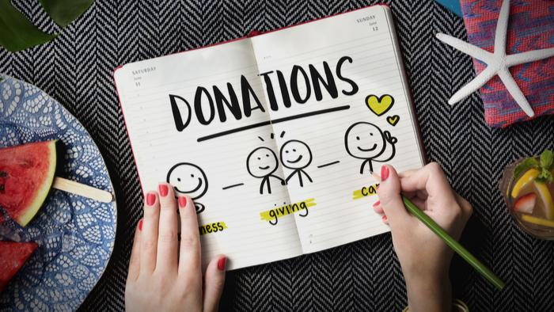

Individual donations are the top way that organisations raise money across the country every year. A recent survey conducted by Netsuite among 350 non-profit organisations in America shows that individuals stills make up the major share of funding for non-profit organisations, followed by earned income, and grants from foundations.

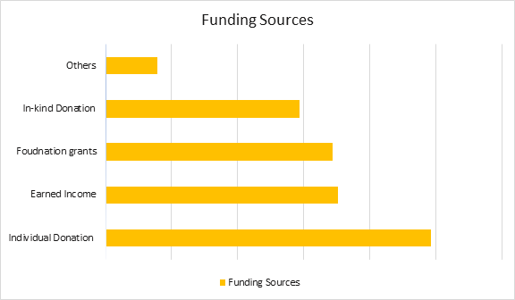

(source: Connecting dollars to outcomes survey)

Focusing on individual donations is a great idea for small or medium-sized organisations to work on cultivating great relationships with individual donors. Individual donors can donate in various forms such as:

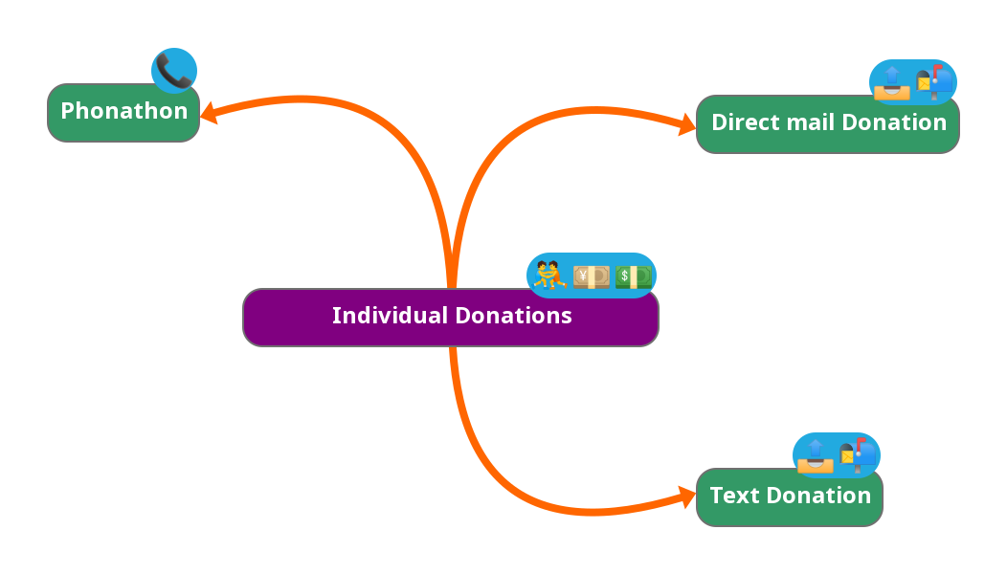

**Direct Mail Donations:**

What is that?

In the form of checks, contributions received via direct mail are usually made. Typically, donors who use this approach are older and prefer a more conventional method. Direct email donations are important because they help donors form a personal connection with your organisation

How to do it?

Send out an email to potential donors who have responded to the program in the past, or if someone anticipates the response. Try to add extra media resources inside the letter and remember to include the self-addressed envelope

**Text Donation**

Since texting has now become the most preferred mode of communication among people across the world, Text donation can be considered a good way to broaden the size of potential donors for this program.

Text to give[/Text giving](https://www.vodafone.com.au/support/device/premium-services?accordion-id=donating-to-charities-via-premium-service-messages) is carrier-based mobile fundraising. A shortcode (shortened phone number), a campaign keyword, and a predetermined donation amount are simply set up by nonprofits. They simply text the keyword to the shortcode whenever donors are motivated, and the donation sum automatically gets credited to their cell phone bill

**Phonathon:**

Phonathon is a fundraising campaign that requires volunteers to ask for contributions by calling donors. Although not the best and assured way to receive grants, it helps to humanize your organisation and introduce the group to different people. Consider one of the best ways to introduce the program to donors and raise awareness.

Standardised scripts and volunteers need to be prepared and well trained before calling. Use Phonathon management software to manage and update donor database, for tracking call results, and automatic pledge verification via email

Some of the good Phonathon management systems are:

[Wilson Bennett Technology](http://www.wilson-bennett.com/)

[RNL Campuscall:](https://www.ruffalonl.com/higher-education-fundraising-management/annual-giving-alumni-giving/phonathon/phonathon-software/)

[VanillaSoft](https://www.vanillasoft.com/solutions/business-function/fundraising)

[Contact Space](https://www.contactspace.com/phonathon-software)

* **In-Kind donation (donation of facilities, supplies)**

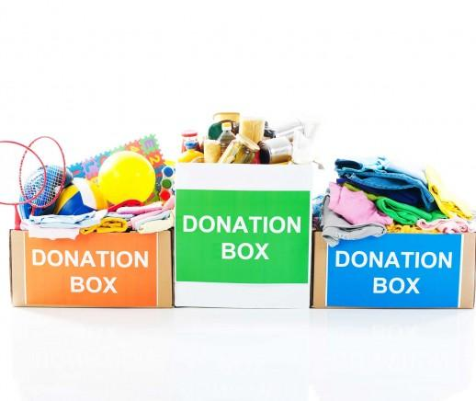

* What is an In-kind donation?
  + A non-cash contribution made to a non-profit organization, including products, services, time, and knowledge, is an in-kind donation. Individuals, businesses, and organisations can make donations of this kind. In-kind contributions typically come from businesses with which the nonprofit has an ongoing partnership or friendship. In-kind donations help to alleviate the financial burden and allow the projects to be undertaken by non-profits to host the activities they need.
* What can be An In-kind donation?
  + Physical property (stuff), intangible property (copyrights, trademarks, intellectual property), facilities, and rent-free space include in-kind donations.
* Why does In-Kind donation help?
  + In-Kind donation help non-profit organisation access goods and services that would otherwise unaffordable or free up resources to spend on something else
* Problem with In-kind?
  + Problems arise when donors donate parts that are not relevant to the needs of the organisation. Unsolicited in-kind gifts will cause physical storage space problems, make use of the gift, and actually have no need for it.
* Way to solve this problem
  + Create a Gift Acceptance Policy in order not to turn your office into a mess, which will help donors give the best In-kind gift support to your mission. An ideal gift acceptance policy form will highlight:
* The kinds of gifts you accept
* The kinds of gifts you don’t accept
* Who you accept gifts from (individuals, corporations, governments)
* What kind of gifts are only accepted with a review (your own, or legal counsel)
* How gifts will be recognized

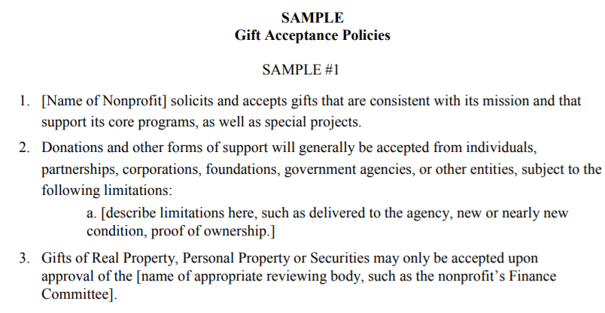

(Source:<https://www.councilofnonprofits.org/sites/default/files/documents/SAMPLE%20Gift%20Acceptance%20Policies.pdf>)

* **Grants from foundations (Community foundation)**

Grants from Community Foundations are sums of money distributed by local, state, or national foundations. In reality, these foundations are non-profit organisations that are managed by the organisations as a way to help raise support from other non-profits. It is possible to apply for grants and get them annually. Some foundations have a rigorous application process, while others will grant the grant amount to a non-profit that they choose internally.

* The disadvantage of Grants funding
  + Time-Consuming: Lots of research and paperwork needs to be done. There are various grant package supports, but the organisation needs to find which fits the most for themselves. Providing unique ideas and the appropriate convincing proposal is the only way to help non-profit businesses receive the grants.
  + Difficult to Receive: Competition is fierce, and the rate of success is low. Approximately 2,700 grant proposals are submitted on average daily; less than 200 receive funding.
  + Uncertain Renewal: Most grants are short-term period, when it runs out, the program needs to start over.

List of potential foundations:

<https://www.snpo.org/grantstation/>

<https://www.philanthropy.org.au/seek-funding/Directory-of-funders/>

<https://www.thegrantshub.com.au/>

<https://www.grants.gov.au/Go/List>

<https://communityfoundation.org.au/>

* **Earned income (fee for service)**

**Type of earned income should be considered:**

**Membership model:**



Tactical planning:

Event: Providing partner/membership for people who attend the program

Goal: Fundraising and generate more income

Target customer: People who participate in the program

How: Set up a membership level: Connected member, active member, and impact member. With these three different amounts of money, they have to pay monthly including different services. The higher the level of membership, the more services they get

Key Success: Easy to attract people with affordable donations and enough service to meet their needs. Payment can be done online or offline.

Budget: To be discussed

Issue: Creating enough donor base who would want to donate regularly.

**Putting up Ice cream and soft drinks stand during the program**

Tactical planning:

Event: Selling ice cream and soft drinks with the help of a small stand run by the organisation’s volunteers

Goal: Fundraising and generating side income

Target customer: Youths, parents, and people who participate in the programs

How: Set up a small store next to the training place and provide cold beverages, hot coffee, and snacks to attract people.

Key Success: Easy to attract people with affordable price

Budget: Small budget

Issues: Not enough demand to run the stand

**Outcome 3: Customer insights about the target group**

**Purpose:**

To better design a marketing strategy that conforms to "HWYP", questionnaire surveys are a good way.  Our main purpose is to collect the opinions and suggestions of residents living in various states of Australia about HWYP, and non-profit organisations in general. The Online Survey we use is a cheap (low cost), fast, and efficient method. The collected data will provide great help for everyone to understand the target market and the current situation, and the future development of HWYP. The data results from the surveys are often authentic and reliable.

**How do you do it?**

We have divided the questionnaire survey into three steps.

**The step 1 is to prepare questions:**

We have used a free survey webpage called: SurveyMonkey, to create a questionnaire for HWYP. There are 7 questions in total, and it should take about 4-5 minutes to complete it. This includes a structured questionnaire (simply answering "YES" or "NO" questions) and an Unstructured questionnaire (open-ended question).

Besides, this questionnaire will also provide information about HWYP, so that the interested ones can learn more about it.

This questionnaire will have a web link, and our team members are prepared to share this link amongst our social circle, and perhaps, phoning corporates.

The survey web link: **https://www.surveymonkey.com/r/QKV9L2X**

**Step 2: Information collection:**

Once we get some response from the respondents, we will collect that information.

**Step 3: Analyse the data:**

Since February 19, we have spent three days to collect the respondents' responses. As of February 21, we have collected a total of 13 responses. Below, we will summarize the results of each question.

Question 2 is to find out whether residents living in Australia have heard of HWYP. 30.77% (4 people) responded “Yes”, and the remaining 69.23% (9 people) responded “NO”.

Question 3 is to know the target group of our respondents who like to get involved with nonprofit organisations. We got 53.85% of the respondents aged 16-25 years, and 46.15% of the respondents aged 26-49 years.

Question 4 is to find out which state is more active. 100% of the responses we get are from New South Wales.

Question 5 is to find out how many people are willing to participate in non-profit organisation. In addition, this question is also an open-ended question, because we want to understand what prevents everyone from participating in the event. We concluded that the main reason is: busy work.

Question 6 is an option question, because we consider the completion rate of the whole survey, because this problem is related to the service area (QLD) of HWYP. The purpose of the question is to find out how active people are in HWYP. 36.36% of the people are willing to participate, but 63.64% are not willing to participate.

Question 7 is to know which platform is the most active. The main platforms we get are from social media, such as Facebook, instagram, 61.54%. The other 15.38% came from TV / ratio, and some 23.8% came from other platforms, such as activities held by the company.

Question 8 is to collect information about how non- profit organisations can better support the work of volunteers. Although we didn't collect a lot of suggestions, because most people have no volunteer experience, we still got some responses.

In conclusion, the main service state of HWYP is QLD. Although all the replies received in this survey are from NSW, we still got 30.77% of the people know about this organization. The data shows that even if HWYP service area is not in NSW, it has a certain popularity, which is a good trend. At the same time, these respondents are also among the clients of HWYP (16-25 years old).

Question 5 shows that the main reason that hinders people from participating in non-profit activities is busy work and study. At the same time, we also collected people's suggestions on non-profit volunteers from question 8. For example, it's not a boring job to raise people's awareness of non-profit organisation. In addition, the organization should also carry out activities with high interest and high participation of volunteers, it's not just a single form of activity, such as lectures and classes. Moreover, the activities organized by the activity party should have a clear activity structure, division of work and the best arrangement during the holidays, because the volunteers will feel that they are not wasting time and can better arrange their working time.

Although in question 6 we got 63.64% of people's responses that they were unwilling to participate in HWYP activities, I believe that the personal opinions collected above can be modified. At the same time, this survey has a time problem, because we don’t have much time to collect more replies, and there is a regional limitation here. For example, most of the survey link shared by our group members live in NSW and their friends in NSW.

Everyone can get more event information from social media, which is good for HWYP because this platform is low-cost.

The above data will be shared with other outcomes in this report.

**Outcome 4: Creating a Fundraising Event**

** **

It can be noted that fundraising events attract widespread volunteers, donors, and sponsors when intended for fundraising, for charitable organisations such as NGO’s considering it would be of the highest benefit to either be involved in an existing charitable event sponsored by a major NGO, or for an individual event to be created for Horse Whispering Youth Program. To maximise the success rate, Horse Whispering Youth Program should utilise hashtags and plan the fundraising event in December, as statistics state there's a 30% higher donation rate in December and on the last 3 days of the year (<https://nonprofitssource.com/online-giving-statistics/>).

**Step 1: Create an active database**

* To maximise the awareness of potential charitable fundraisers and for potential donations, it would be of the highest benefit to develop an ongoing database that links to your emails and sorts contacts into a spreadsheet to allow for a correspondence list to be utilised by the business. This could be achieved through:

**Option 1: Utilise Excel for a Contacts Database and do a monthly/ weekly update for contacts in accordance with emails**

* Create an excel spreadsheet as per the table below:

|  |  |  |
| --- | --- | --- |
| Contact | Company | Email/Phone |
|  |  |  |
|  |  |  |
|  |  |  |
|  |  |  |

* Update this spreadsheet either weekly or monthly with relevant contacts by selecting emails whose contacts would be relevant with a star daily and adding to it.

**Option 2: Using the contacts access database template**

* Prepare the database for use by opening up the contacts template on Microsoft Access:

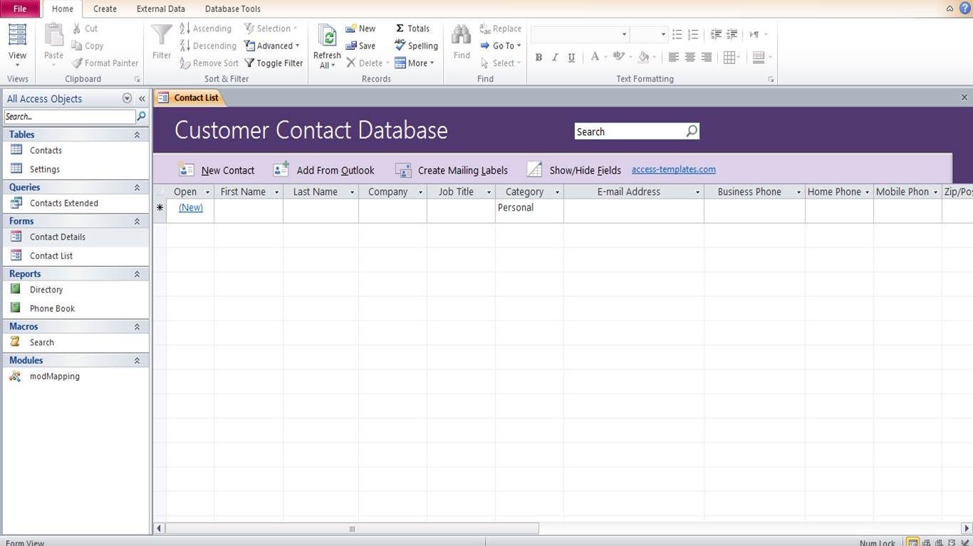

* Either create a new Microsoft Outlook account or use an existing account as the primary email for easier accessibility and connection with emails. To add contacts from Microsoft Outlook:

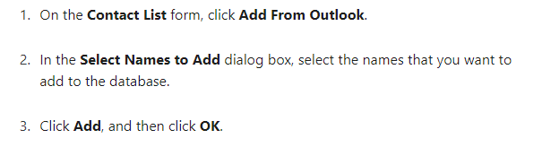

* Through regularly maintaining this database, a display report can be printed by clicking in the navigation pane under **Reports** and selecting the appropriate report

For further information, refer to this website: <https://support.microsoft.com/en-us/office/use-the-contacts-access-database-template-8b402426-db20-4a8f-ac4b-9031498c568e>

This ongoing creation of a contacts database will enable you to have access to a list of potential sponsors/donors for future fundraising events or donation opportunities

**Step 2: Contact Possible Donors/ Sponsors before fundraising events**

* To gain greater widespread awareness, it would be of benefit to contact the following companies using the given contact details and give a brief description of the Horse Whispering Youth Program, ask if they would be happy to potentially donate funds, particularly at the time of creating a fundraising event.

1. JBHIFI - 1300 730 548
2. Seek - **1300 658** 700
3. Collins Food Group - +61 7 3352 0800
4. Pacific Equity Partners - *+61 2 8238 2600*
5. Atlassian - Fill out a general inquiry form on https://www.atlassian.com/company/contact/general-inquiries
6. Event Hospitality and Entertainment - (612) 9373 6600 or email info@evt.com
7. Flight Centre - 133133
8. BHP Bilton - 1300 55 47 57
9. Corrs Chambers Westgarth - +61 7 3228 9333
10. PWC - **+61 2 8266 0000**.

These were the top 10 companies that supported charitable organisations in Australia through donations and fundraising in 2020.

**Alternatives to Creating an Event**

**Option 1: Enlist in an Existing Successful Event**

To attract potential sponsors and donors, the Horse Whispering Youth Program could alternatively become involved in the following widespread events in Australia partnering with the following main organisations which conduct the below events:

1. Australian Red Cross: Red Shield Appeal- Annual event fundraising for the Salvation Army in support of various programs
2. Vinnies - CEO Winter Sleepout - Support of homelessness supported by business leaders
3. Park Run Queensland - Weekly event which operates in various locations throughout Australia
4. JDRF - One Walk - 5km Fun run in support of Diabetes

For the Horse Whispering Youth Program to become involved in the following events, it is required to contact the following organisations and enquire as to whether this would be possible to do so.

**Option 2: Virtual Event**

Instead of gathering, virtual events by using technology are becoming popular among non-profit organisations. This event requires less planning, less cost, and can raise as much as funds. There are many more possibilities for your virtual fundraising event, including:

* A live-streamed speech and a program
* A video conference presentation with questions and answers
* A video conference trivia game or challenge
* A virtual sport

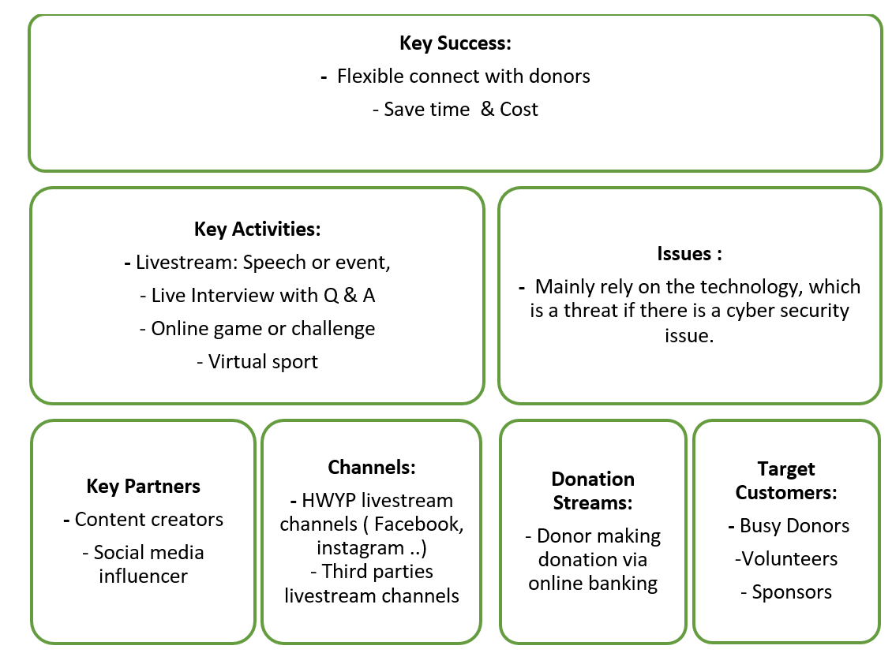

**Option 3: Sport event and social media challenges**

The current issue of donors who are reluctant to donate is that they get pressured to donate a big amount of money, a pressure to donate regularly with their unstable economic condition. Especially, during this economic downturn resulting from the Covid-19 that affected many donors. The key advantage of this suggested event is easy, affordable, and targeting various classes of donors.

**Charity Event Idea: Key planning**

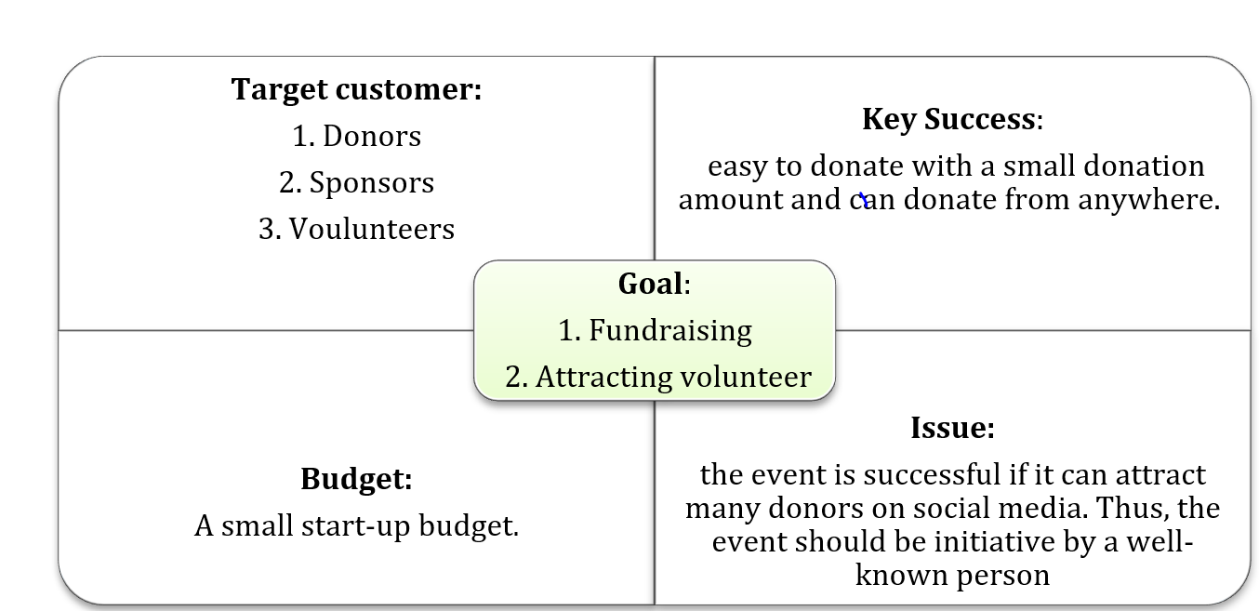

**- Process**

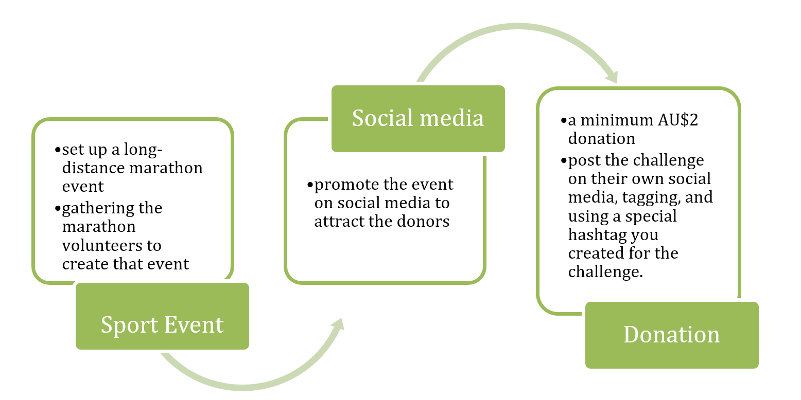

**Ways to get media coverage for this event**

1. **Major Broadcasting Companies**

Contact a primary television production company such as 9 News in an attempt to get coverage from Current Affair, ensuring they broadcast the details to donate when providing live coverage of the event. This can be achieved by accessing this link <https://9now.nine.com.au/a-current-affair/tell-us-your-story> and entering the details for “Tell us your story”.

.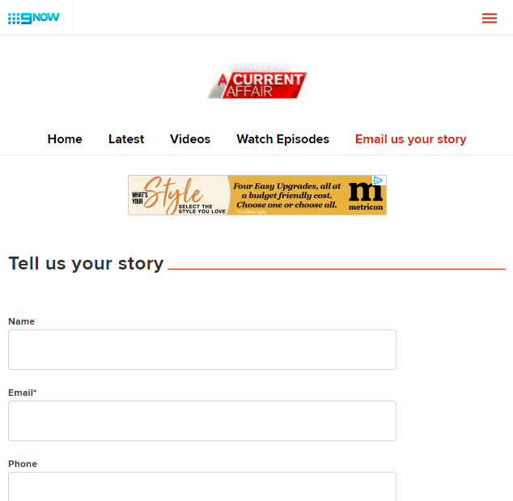

1. **Influencers to promote on social media**

It would be beneficial to use connections such as Apollo Jackson from the Bachelorette and to try contact influencers such as Britney Saunders, a popular Australian Youtuber, Kayla Itsines, a fitness guru, and Emilly Skye via popular social media channels such as Instagram, Twitter, and Facebook. These influencers could then utilise Horse Whispering Youth Campaign’s hashtags to further advertise the event.

 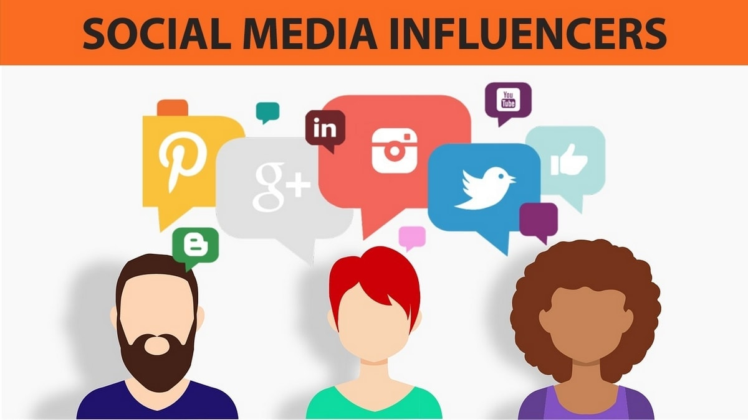

1. **Campaigning with paper ads locally**

Take advantage of advertising in surrounding areas in Queensland through utilising campaigning via posters, including on it a fundraising link, hashtags, stating the primary event details, and graphics to attract attention.

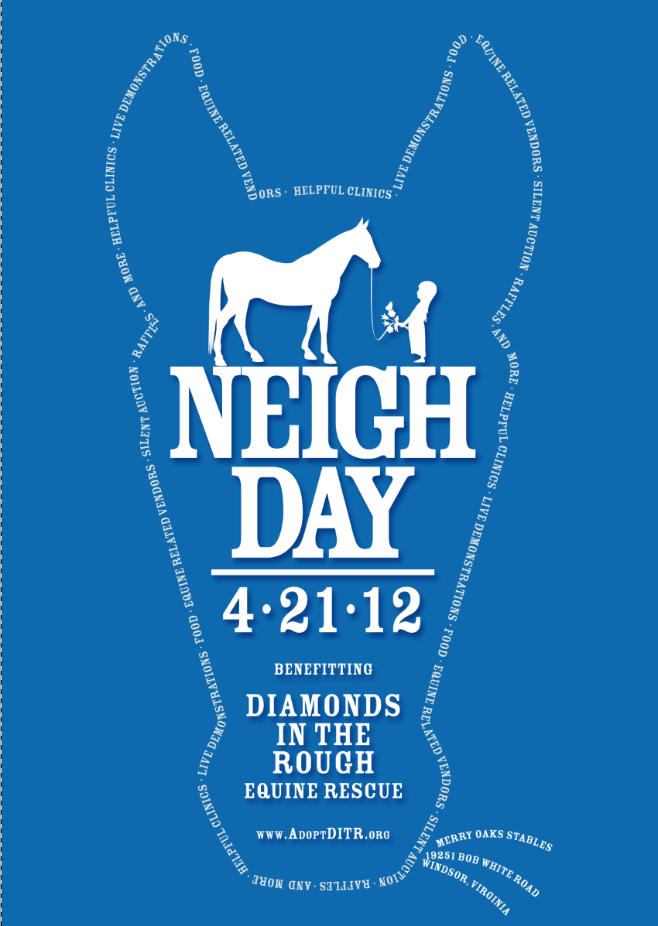 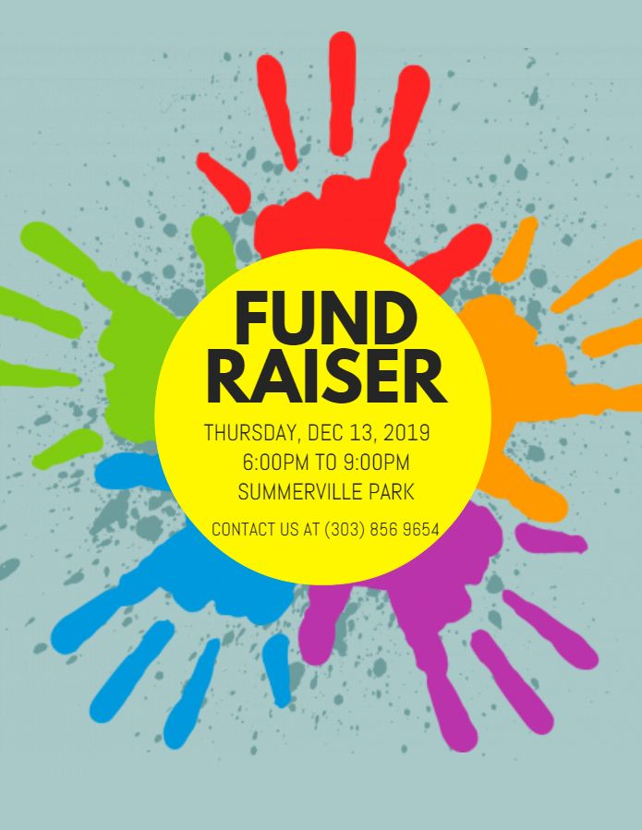

**Conclusion**

**After significant research and assessment of data, this report contains extensive information on recommendations which are focused upon social media branding and strategies, targeting sponsors, insights about the target group and organisation of an event with media coverage, expanded upon below:**

1. **Take advantage of Google Ad Grants for sponsoring, Optimise an effective donation campaign and take advantage of social media platforms particularly social media in addition to developing an effective content strategy using the effectiveness of hashtags.**
2. **Explore the various options for collecting individual donations, in kind donations, the grants available from foundations and methodology for earned income discussed in depth detail in Section 2.**
3. **A survey has been developed upon to gain customer insights as to the target group and as per the collected survey responses its been revealed …. (General Comment).**
4. **It’s recommended to establish a long distance marathon event and maximise media coverage to achieve the best possible outcome which attracts donations. As per the current COVID Conditions, this could be achieved through Enlisting in an existing successful event such as ParkRun or Hosting a virtual event.**

**It is in the best interests of the Horse Whispering Youth Program to take on board these recommendations to achieve their objective of an effective marketing campaign to attract various sponsors and donors willing to provide support to this program. In relation to the contents of this report, its inclusive of current data collected from various age groups, companies and charities through survey responses and past data inclusive of database information, trends and statistics. However, since many phone calls went straight to the companies hotlines the survey responses were limited from companies themselves. Hence, this report consists of recommendations which compose of a strategic marketing plan based upon the current operation and objectives of the Horse Whispering Foundation.**